Fix OneDrive error code 0x8004da9a

OneDrive is a very powerful cloud storage platform that provides various utilities to the users. Despite being one of the best a few hiccups here and there are inevitable. One such error is 0x8004da9a, but before getting into the troubleshooting methods let’s look as the reason behind this issue.

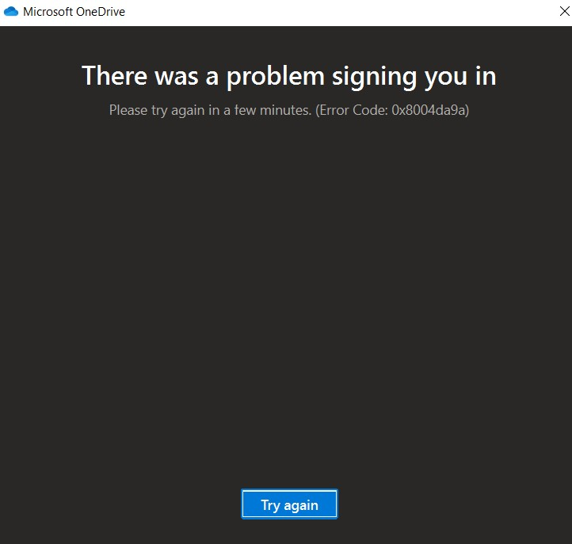

### Why does this error occur?

To resolve any error, it’s important to go into the crux of the issue and there can be various reasons for this problem to occur. However, this issue is majorly faced by users who are availing of Microsoft 365 services through unauthorized mediums.

As an initiative to curb the widespread use of Office 365 through unlicensed software, Microsoft performs routine checks on accounts that it finds dubious and peculiar. So, it’s highly probable that their account will remain closed if someone falls under both of these categories.

To avoid the risk of getting the account suspended, it’s highly recommended to use an OneDrive and other services through licensed software.

If you are using a licensed product and still getting this error here are a few methods to resolve the issue.

### Kill the instance

While working on the app if you face this issue, you can try to forcefully stop the app from running on your machine. Technically speaking it’s called killing the instance.

1. Right click on task bar, go to Task Manager.

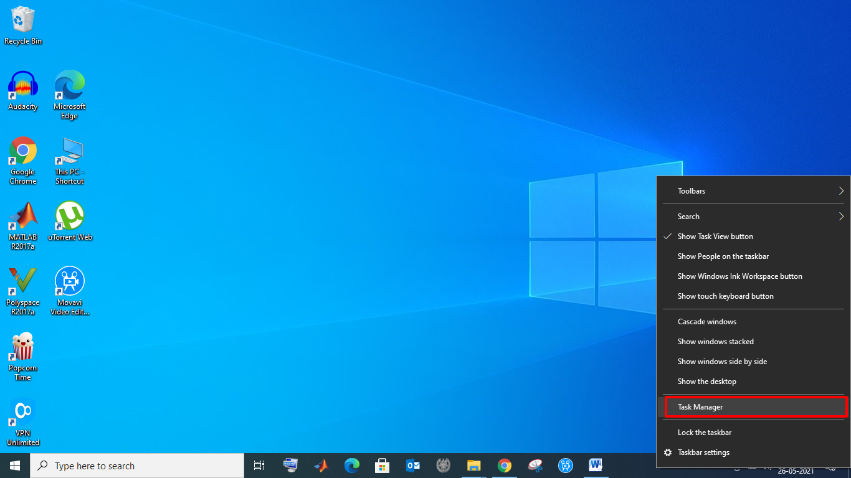

1. Search for OneDrive, and click option ***End task***.

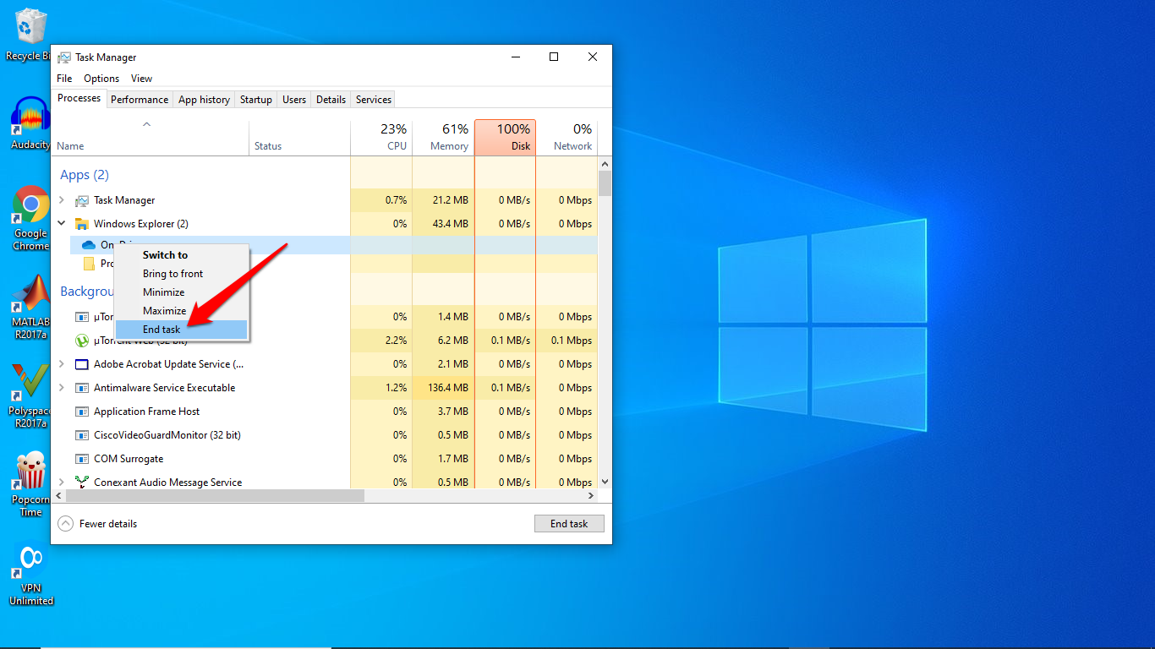

Once this step is done, open the OneDrive app on your machine to check if it’s working.

### Disable the VPN

If the above method does not work for OneDrive desktop app and you still face this issue. So, the first and foremost step is to make sure that you have disabled VPN or set off the proxy services installed in your machine, if there is any. This step will ensure that there is no hindrance to login to OneDrive application.

If you still have this issue try further methods mentioned below.

### Login through OneDrive web

If you are getting the 0x8004da9a error on the one drive app then try login through the OneDrive web.

1. Navigate to the [link](https://onedrive.live.com/about/en-gb/signin/) and log in using your credentials. This procedure is for anyone who is using a personal, school or work account on OneDrive.
2. If you’re able to open the OneDrive on web and access your data then try to reset your account.

### Reset the account

Like mentioned above, if you are getting this error next step to solve this issue is to reset the OneDrive account. Resetting of the account helps in resolving sync issues, if any. You don’t have to worry as you won’t lose any data in the process.

Let’s look at the steps to reset the OneDrive account

1. Open the run window by pressing E:\DIGITBin\Fix onedrive error code 0x8004da9a\windows.pngand **R** simultaneously.
2. Once the dialog window pops up copy ***%localappdata%\Microsoft\OneDrive\onedrive.exe /reset***.

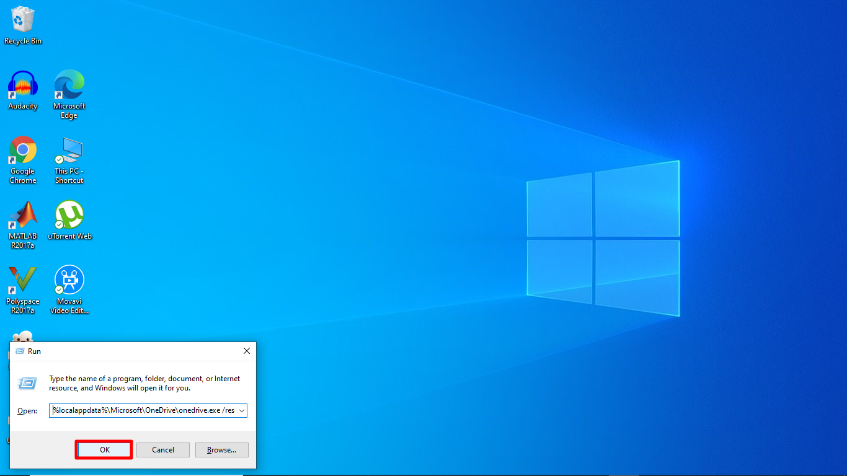

1. If this doesn’t work and you get the message Windows cannot find..." then try using ***C:\Program Files (x86)\Microsoft OneDrive\onedrive.exe /reset.***

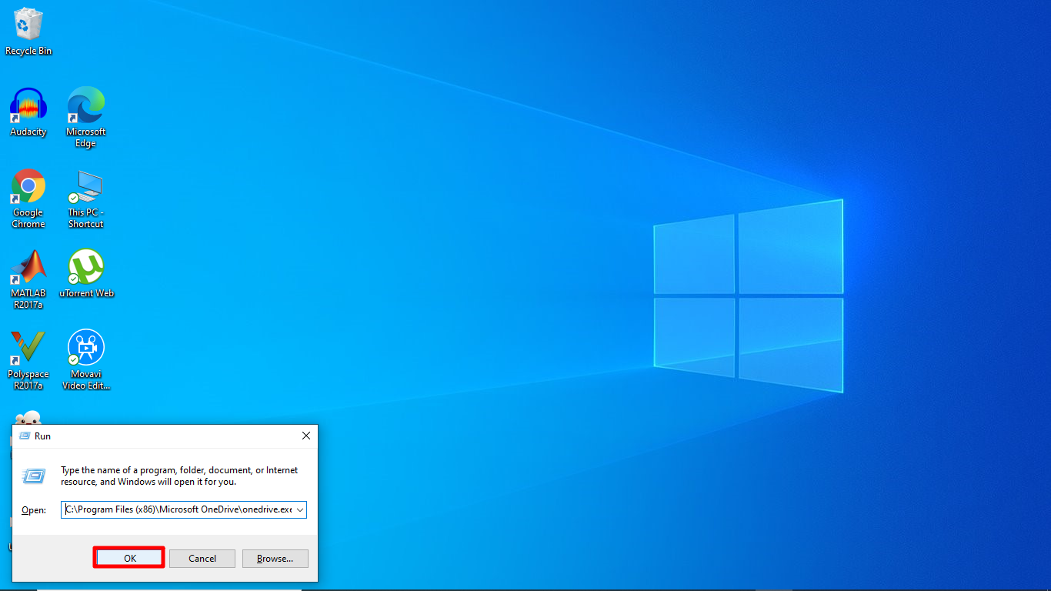

1. Once the resetting is done, open the OneDrive desktop app.

### Reinstalling the app

As a last resort try this method to uninstall and installing the app again. For this you need to follow these steps:

1. Go to E:\DIGITBin\Fix onedrive error code 0x8004da9a\windows.png and type OneDrive.
2. Right click and select the option Uninstall.

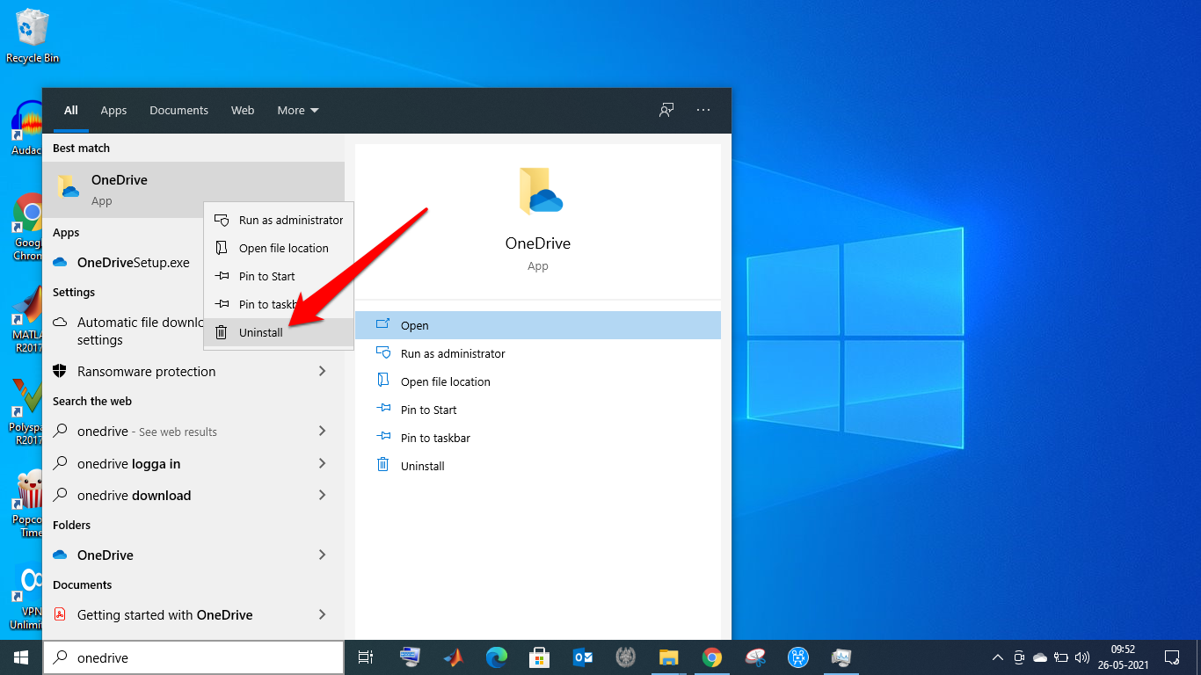

1. [Reinstall](https://www.microsoft.com/en-ww/microsoft-365/onedrive/download) the app once this process is done.

Besides these methods you always have option to post your query/issue on [Microsoft forum](https://answers.microsoft.com/en-us) to get the technical assistance directly from the concerned person.

Hope this article helps you in solving your queries. Do let us know your thoughts/queries in the comment section.